Pozdravljeni.
Upam, da ste se spočili in ste pripravljeni na nove delovne podvige.
Danes bo vaša prva naloga, da rešite priloženi delovni list. Prvi del učnega lista je razlaga, ki naj vam bo v pomoč pri reševanju. Tam, kjer piše 'practice i' po spodnjih primerih napišete vprašanje in odgovor, ki naj bo pozitiven. V drugi nalogi 'practice ii', pa zapišete vprašanja in nanje odgovorite negativno. Učni list je v obliki wordove datoteke, zato lahko povedi vtipkate neposredno na drugo stran v za to namenjen prostor. Nato mi dateteko pošljite po elektronski pošti. Lahko pa povedi napišete tudi na roko na list ali v zvezek, napisano fotografirate in mi prav tako pošljete po elektronski pošti. Poskrbite le, da se bo iz fotografije dalo prebrati, kar ste napisali.
Hvala za sodelovanje in lep pozdrav,
Vaša učiteljica.

Food (Countable and Uncountable)
What do you have in your refrigerator?
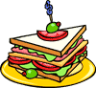
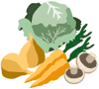

Questions
- Is there any milk in the fridge?
- Are there any biscuits in the cupboard?
- Do you drink much water?
Responses
- Yes, there is. There is some milk.
- Yes, there are. There are some biscuits.
- Yes, I do. I drink water everyday.
Follow-up Questions
- How much milk is there?
- How many biscuits are there?
- How much water do you drink everyday?
Responses
- There is only a little milk.
- There are only a few biscuits.
- I drink a lot of water everyday.

Practice i Use the information to practice asking and responding in the positive. i.e.
- apple juice/in the fridge
A) Is there any apple juice?
B) Yes, there is some apple juice in the fridge.
- potatoes/in the vegetable box
- bread/in the bread bin
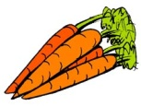
- mushrooms/in the cupboard
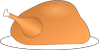
- chicken/in the freezer
- eggs/in the fridge
- sweetcorn/in the pantry

Practice ii Use the information to practice asking and responding in the negative. i.e.
- potato crisps
A) Are there any potato crisps?
B) No, there aren’t any potato crisps.
- apple pie
- noodles
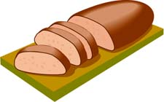
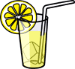
- coffee
- lettuce
- rice
- carrots

Type your sentences here:

