Reading Mikey is offering to help his mum with some grocery shopping.
Mikey: Mum, I’m going into town to meet some friends. Do you need anything from the supermarket?
Mum: Oh, yes please, Mikey. I need some chicken for dinner tonight.
Mikey: Okay. How much chicken do you want?
Mum: Well, there isn’t any chicken in the freezer so I’ll need about 500g.
Mikey: Do you want chicken wings or some chicken breast?
Mum: Chicken breast please. Oh, and can you get one or two potatoes too? We only have a few left.
Mikey: Got it. I’ll buy some chicken breast and a couple of potatoes. Anything else? Do you need any bread or milk?
Mum: No, we have a loaf of bread and there are two cartons of milk in the fridge.
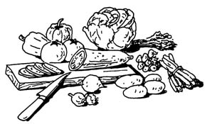
Mikey: Alright. See you later.
Mum: Thank you Mikey. See you later.

- How much chicken is Mikey going to buy?
- How many potatoes will he get?
- What do they have in the fridge?

Application Discussion/activity.
Make a list of common foods and drink that you usually have every week. Decide if each one is countable or uncountable and write them down in the box below. Then, interview your partner about their eating and drinking habits.

COUNTABLE | UNCOUNTABLE

